Variables excluded based on correlation matrix. 10 fold cross validation used to calculate accuracy.

1. No variables excluded; no PCA; classes 1&2 and 3&4 lumped

Best classifier: Cubic SVM

Accuracy = **79.2%**

AUC = 0.86

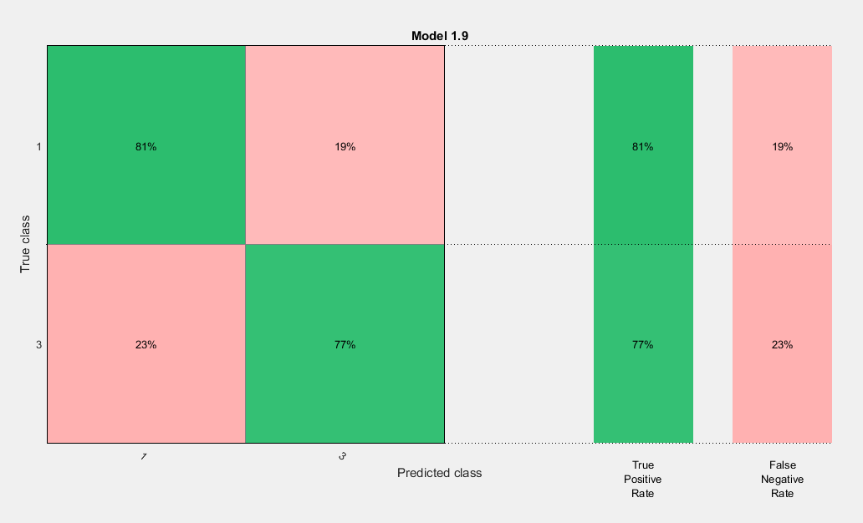

1. Variables 3,4,18 excluded; no PCA; classes 1&2 and 3&4 lumped

Best classifier: Cubic SVM

Accuracy = **83.1%**

AUC = 0.88

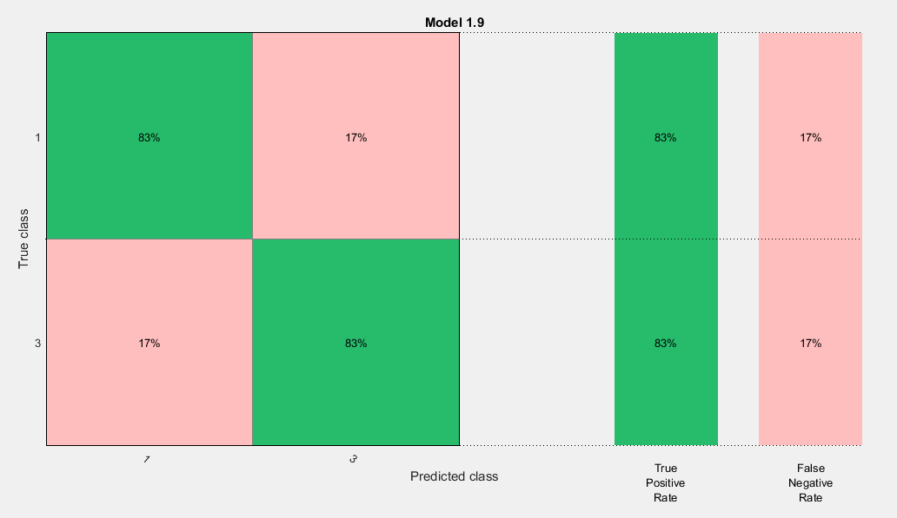

1. Variables 3,4,8,10,18 excluded; no PCA; classes 1&2 and 3&4 lumped

Best classifier: Cubic SVM

Accuracy = **79.2%**

AUC = 0.87

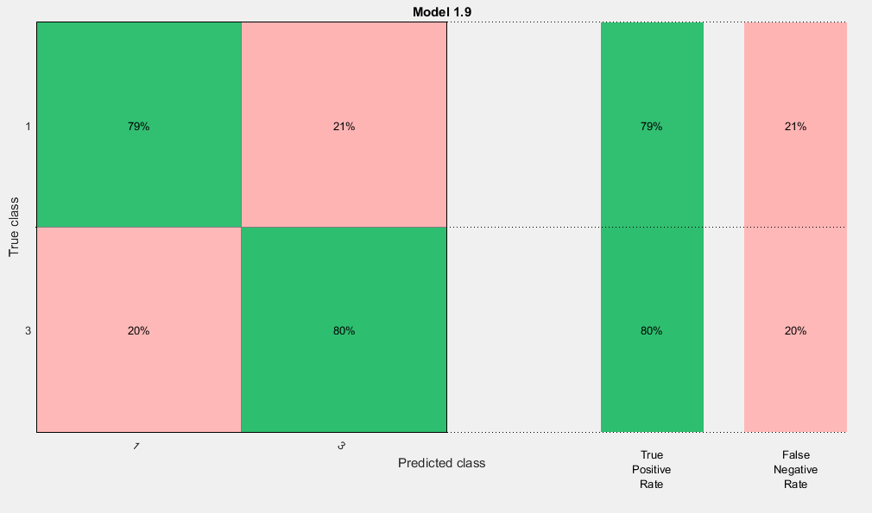

1. Variables 1,3,4,8,9,10,18,21 excluded; no PCA; classes 1&2 and 3&4 lumped

Best classifier: Cubic SVM

Accuracy = **79.7%**

AUC = 0.86

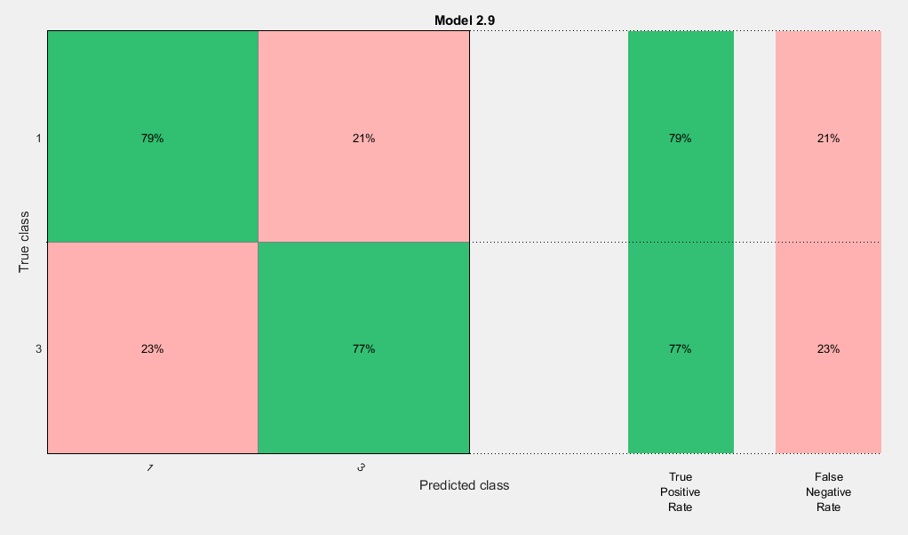

1. No variables excluded; no PCA; only classes 2 & 3

Best Classifier: Cubic SVM

Accuracy = **85.3%**

AUC = 0.92

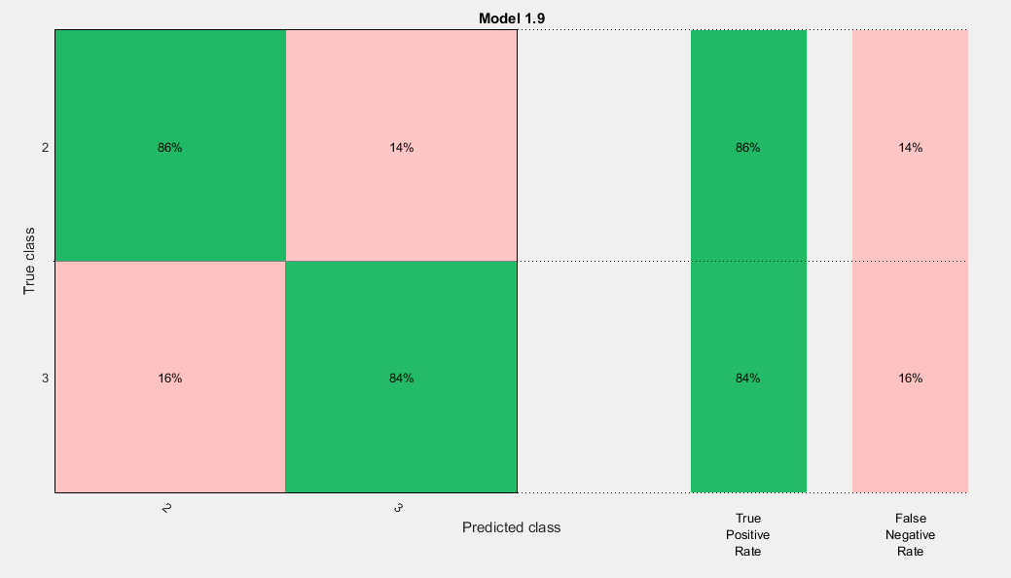

1. Variables 3,4,18 excluded; no PCA; only classes 2 & 3

Best Classifier: Cubic SVM

Accuracy = **85.3%**

AUC = 0.92

